

Dear Parents,

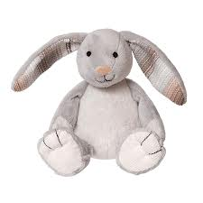
We look forward to welcoming your child to La Case.
Would you be so kind to bring these few personal belongings :

- A plush or paw or cuddly toy that will accompany it as a transitional object between the house and the nursery
- A pacifier (if he has one)
- A sleeping bag (if he is used to it)
- A t-shirt with the smell of mom or dad that can reassure the child during the^{1st} naps

- 1 or 2 bottles for milk, according to his habits of the day
- A packet of powdered milk if he drinks it during the day

- A bottle for water
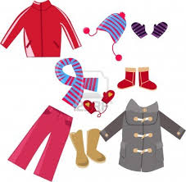
- A set of spare clothes (body - sweater - pants - socks)
- A pair of slippers (if your child walks)
- Woolen or sun Hat - gloves - scarf - snow combi - shoes or boots ... All this in relation to the season
- Care creams (change, face, sun, what he is used to), physiological solution

Please note your child's clothes, to avoid confusion (exchanges, losses, ...)
For any questions, we are all at your disposal.

The Nursery's Educational Team,

